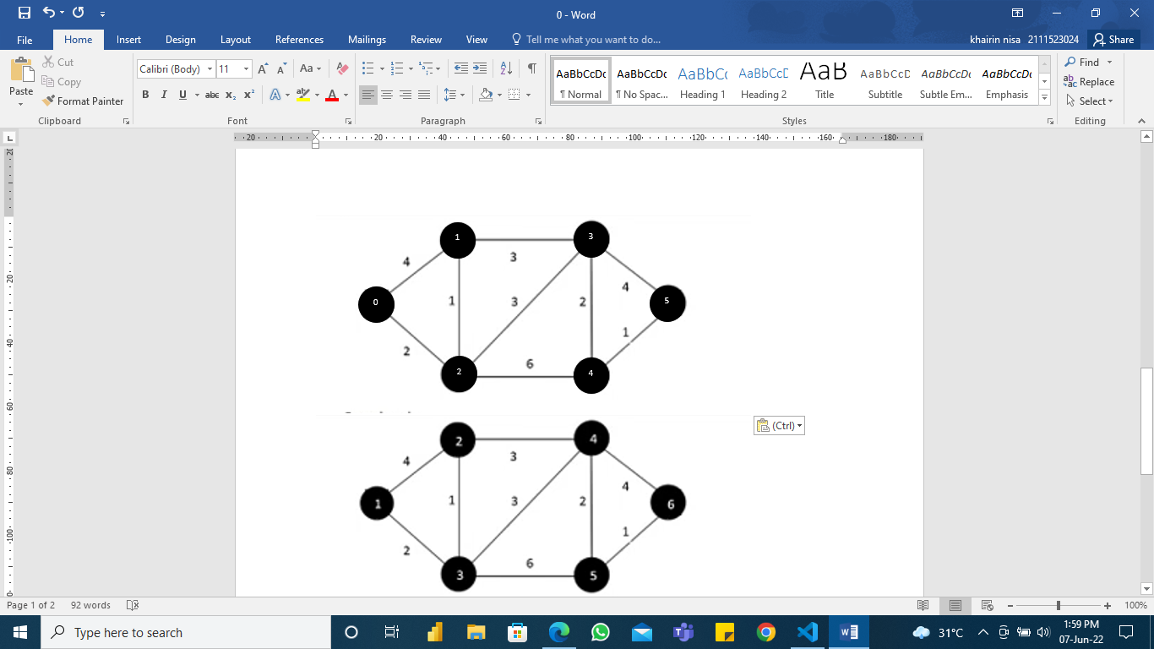

|  |  |  |  |  |  |  |
| --- | --- | --- | --- | --- | --- | --- |
|  | 0 | 1 | 2 | 3 | 4 | 5 |
| 0 | 0 | 4 | 2 | 0 | 0 | 0 |
| 1 | 4 | 0 | 1 | 3 | 0 | 0 |
| 2 | 2 | 1 | 0 | 3 | 6 | 0 |
| 3 | 0 | 3 | 3 | 0 | 2 | 4 |
| 4 | 0 | 0 | 6 | 2 | 0 | 1 |
| 5 | 0 | 0 | 0 | 4 | 1 | 0 |